**Function Specification Document**

Project Name: the Light MeAL service

Revision History

| **Draft Version** | **Date Submitted** | **Deliverable Point of Contact** | **Description of Changes** |
| --- | --- | --- | --- |
| 1.0 | 01/07/20 |  | Initial Draft |
| 2.0 | 01/10/20 |  | Updated based on FSD walkthrough feedback received. |

Table of Contents

1.) Referenced Documents 1

2.) Decision Log 2

3.) Functional Overview 3

4.) System Requirements 5

5.) System Diagram 6

6.) Use Cases and Requirements 10

6.1 Use Case ID: UC-01– User register in the application. 10

6.1.1 Description 10

6.1.2 Actor 10

6.1.3 Trigger 10

6.1.4 Precondition 10

6.1.5 Post condition 10

6.1.6 Assumptions 10

6.1.7 Flow of Events 10

6.1.8 User Pages and Input 10

6.1.9 Transaction /SSO Information 11

6.1.10 Functional Requirements 11

6.1.11 Special Design Consideration 11

6.1.12 Acceptance Criteria 11

6.2 Use Case ID: UC-01– User sign-in in the application. 10

6.1.1 Description 10

6.1.2 Actor 10

6.1.3 Trigger 10

6.1.4 Precondition 10

6.1.5 Post condition 10

6.1.6 Assumptions 10

6.1.7 Flow of Events 10

6.1.8 User Pages and Input 10

6.1.9 Transaction /SSO Information 11

6.1.10 Functional Requirements 11

6.1.11 Special Design Consideration 11

6.1.12 Acceptance Criteria 11

6.2 Use Case ID: UC-02 – Consume Title II income RETURNED FROM SSa composite service during eligibility flow 12

6.2.1 Description 12

6.2.2 Actors 12

6.2.3 Triggers 12

6.2.4 Preconditions 12

6.2.5 Post condition 12

6.2.6 Assumptions 12

6.2.7 Flow of Events 12

6.2.8 User Pages and Input 13

6.2.9 Transaction /SSO Information 13

6.2.10 Functional Requirements 13

6.2.11 Special Design Consideration 14

6.2.12 Acceptance Criteria 14

7.) Reference Document 44

8.) Acronyms 45

Table 19. Reference Documents 39

Table 20. Acronyms 40

# Referenced Documents

The Referenced Documents table provides a summary of the relationship of this deliverable to other relevant documents.

|  |  |
| --- | --- |
| **Document Name** | **Document Attachment** |
| Business Requirement Document |  |

Table 1. Referenced Documents

# Functional Overview

* 1. **PURPOSE**

The intention of this document is to:

* Ensure the business requirements are fulfilled by the functional requirements, and that the functional requirements are adequate to provide a gap-free technical solution.
* Provide input to the product Quality Assurance Team to create test plans and test cases and, eventually, incorporate them back to this document as a single reference document for the business requirement.
* Provide input for customer requirement gathering sessions and performing map and gap analyses.
* Maintain product requirements traceability for customers based on the agreement signed.
  1. **FUNCTIONAL OVERVIEW**

As a part of “The Light Meal Service” application functionality, the system will be implemented:

* Allow user to register the profile.
* Sign-in into the application.
* Show “The Light Meal Service” contact information detail
  + Phone Number
  + Email Address
* To provide the ability to setup a meal service window (Jan 1st to Jan 7th (weekly)– it may be changed in future from weekly to bi-weekly or monthly) in the system.
* System should display “Breakfast”, “Lunch” and “Dinner” group category after selecting the date.
* System should display “Breakfast” option after clicking to “Breakfast” group option.
* System should display “Lunch” option after clicking to “Lunch” group option.
* System should display “Dinner” option after clicking to “Dinner” group option.
  1. **ASSUMPTIONS/RISKS/CONSTRAINTS**

**3.3.1 ASSUMPTIONS**

Listed below are the assumptions that guided the identification and development of the requirements stated in this document. These assumptions are intended to promote mutual understanding, partnership, and quality communication between all stakeholders and the project team.

* Order will be accepted within meal service window.
* User can select meal service for multiple days.
* System has capability to make default mean options for monthly/weekly/yearly subscribed customer.

# System Requirements

|  |  |  |  |
| --- | --- | --- | --- |
| **Use Case No** | **Use Case Name** | **Product Requirement ID** | **Business Requirement ID (Client)** |
| 6.1 | COLA window setup configuration. | FR-CLA-001 | CL.BR.001 |
| 6.2 | Consume Title II Income returned from the SSA composite service during the eligibility flow. | FR-CLA-002 | CL.BR.002 |

Table 3. System Requirements

# System Diagram



# Use Cases and Requirements

## Use Case ID: UC-01– COLA Window setup configuration.

### Description

This use case describes that HIX system has a configurational set up to define the COLA window.

### Actor

1. HIX system.
2. CoM.

### Trigger

Implementation of COLA functionality.

### Precondition

1. Configuration to define the COLA window does not exist in the HIX system.
2. CoM has raise a PIM to setup COLA window.

### Post condition

The system will have the configuration ready to define the COLA window.

### Assumptions

CoM will create a PIM (one month prior to start of COLA window) to provide the start and end dates for COLA window.

### Flow of Events

#### Main Flow

1. The implementation team will switch ON the COLA configuration and define the

start/end date for COLA window based on the input from CoM.

### User Pages and Input

N/A

### Transaction /SSO Information

N/A

### Functional Requirements

|  |  |
| --- | --- |
| **Functional Requirement ID** | **Requirements** |
| CO.FR.01.01 | The system shall build a configuration that will allow the state to define the COLA window (i.e. COLA start date and end date). |
| CO.FR.01.02 | The system shall build a configuration to turn on or turn off this functionality. |

Table 4. Functional Requirements – UC.01

### Special Design Consideration

|  |  |  |  |
| --- | --- | --- | --- |
| **S. No** | **Description** | **Configuration** | **Default** |
| 1. | A configurational set up to define the COLA window. | COLA window start date and end date | Start date- 01/01/9999  and  End date- 03/01/9999 |
| 2. | A configurational setup to define the COLA window. | ON and OFF | ON |

Table 5. Special Design Consideration – UC.01

### Acceptance Criteria

1. The system should have a configurational setup to define the COLA window (i.e. start date and end date) along with configuration switch to turn the configuration ON/OFF.

## Use Case ID: UC-03 –Discrepancy alert for Title II income

### Description

This use case describes the requirement to display a discrepancy alert in the event of a mismatch between the user attested Title II income and Title II returned from the Hub.

### Actors

1. HIX system
2. Individual user
3. Back office (BO) user
4. CSR user
5. Advanced CSR user
6. Super user/MED_BO user
7. CAC user
8. Navigator user
9. TPL-BO user

### Trigger

1. There is a difference/mismatch between Title II income returned from Hub and user attested Title II income.

### Preconditions

1. The user is on income section screen during the single streamlined application (SSAP) flow.
2. The HIX system already has Title II income as per the result of UC-02.

### Post condition

1. The system will display a discrepancy alert if there is any difference between Title II income returned from Hub and user attested Title II income.
2. In cases where the system is unable to invoke SSA composite service, the system will utilize the latest Title II income available in the system to compare with user attested Title II income.
3. The system will display a discrepancy alert if there is any difference between Title II income already on file and user attested Title II income.
4. The system will not display a discrepancy alert if the Title II income returned from Hub matches with the user attested Title II income.
5. The system will not display a discrepancy alert for system driven determination.

### Assumptions

The system will compare the Title II income result from UC-02 with the user attested Title II income and compare for an exact match.

### Flow of Events

#### Main Flow

1. The user logs into the HIX system to create an application.
2. The user clicks on ‘Yes’ on income section screen and selects social security benefits as a source of income.
3. The user provides social security income details on income section.
4. The system compares user attested Title II income with the result from UC-02 and income matches.
5. The system does not display the discrepancy alert.
6. The user clicks on “Save & Continue” button.
7. The system allows the user to proceed and stores the user attested Title II income in the application.

#### Alternate Flow I

1. The user clicks on ‘Yes’ on income section screen and selects social security benefits as a source of income.
2. The user provides social security income details on income section.
3. The system compares user attested Title II income with the result from UC-02 and income does not match.
4. The system displays the discrepancy alert (Figure 8)
5. The user either proceeds with the amount or updates the Title II income and clicks on “Save & Continue” button.
6. The system allows the user to proceed and stores the user attested Title II income in the application.

#### Alternate Flow II

1. The user clicks on ‘Yes’ on income section screen and selects income source other than social security benefits as a source of income.
2. The user clicks on ‘Save and Continue’ button to proceed.
3. The system displays the discrepancy alert to provide the social security benefit details (Figure 7).
4. The user provides social security income details on income section.
5. The system compares user attested Title II income with the result from UC-02 and income matches.
6. The system does not display the discrepancy alert.
7. The user clicks on “Save & Continue” button.
8. The system allows the user to proceed and stores the user attested Title II income in the application.

#### Alternate Flow III

1. The user clicks on ‘No’ for the question that asks the user if the member has any income on the income page.
2. The system already has the Title II income from UC-02.
3. The system displays an alert (Figure 6) to the user to provide social security benefit details.
4. The user does not provide income details & proceed in SSAP flow.
5. The system considers the Title II income as $0.

#### Alternate Flow IV

1. The user logs back into the HIX system to report income RAC.
2. The user clicks on the income RAC button and landed into income section.
3. If the system is not able to ping the SSA to invoke the SSA composite service. Hence, the system identifies the latest Title II income available in the application (it can be user attested at the time of original application OR updated via PDM process OR manually verified by back office user).
4. The user provides income details on income section.
5. The system compares user attested Title II income with Title II income already available on the application.
6. The system displays a discrepancy alert (Figure 8)
7. The user either proceeds with the amount or updates the Title II income and clicks on “Save & Continue” button.
8. The system allows the user to proceed and stores the user attested Title II income in the application.

#### Alternate Flow V

1. The user logs back into the HIX system to report a change (other than income change) for e.g. change in address.
2. The user clicks on update address RAC button and landed into profile section.
3. The user updates the new address in the system.
4. The system invokes the SSA composite service and receives the latest Title II income from the Hub.
5. The user proceeds through the income section in SSAP flow.
6. The system compares user attested Title II income with the Title II income returned from the Hub.
7. The system displays an alert for the discrepancy (Figure 8).
8. The user either proceeds with the amount or updates the Title II income and clicks on “Save & Continue” button.
9. The system allows the user to proceed and stores the user attested Title II income in the application.

### User Pages and Input

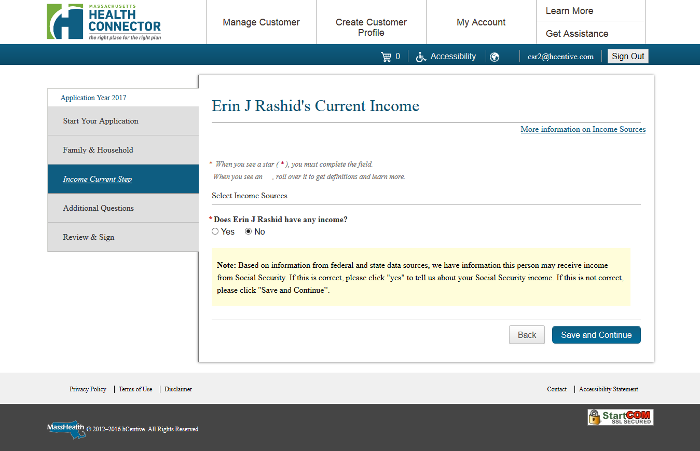

Figure 6| Income Alert Message 1

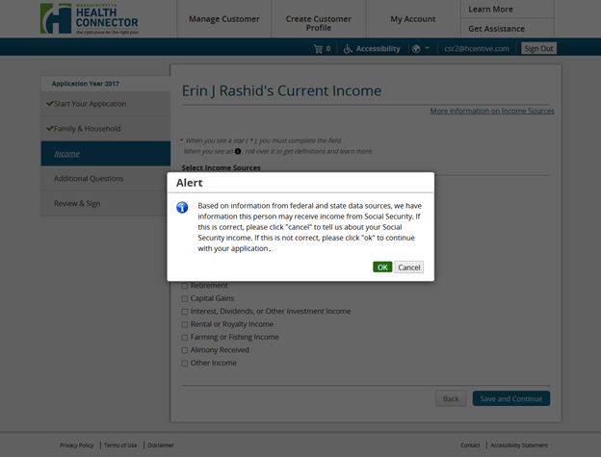

Figure 7 |Income Alert Message 2

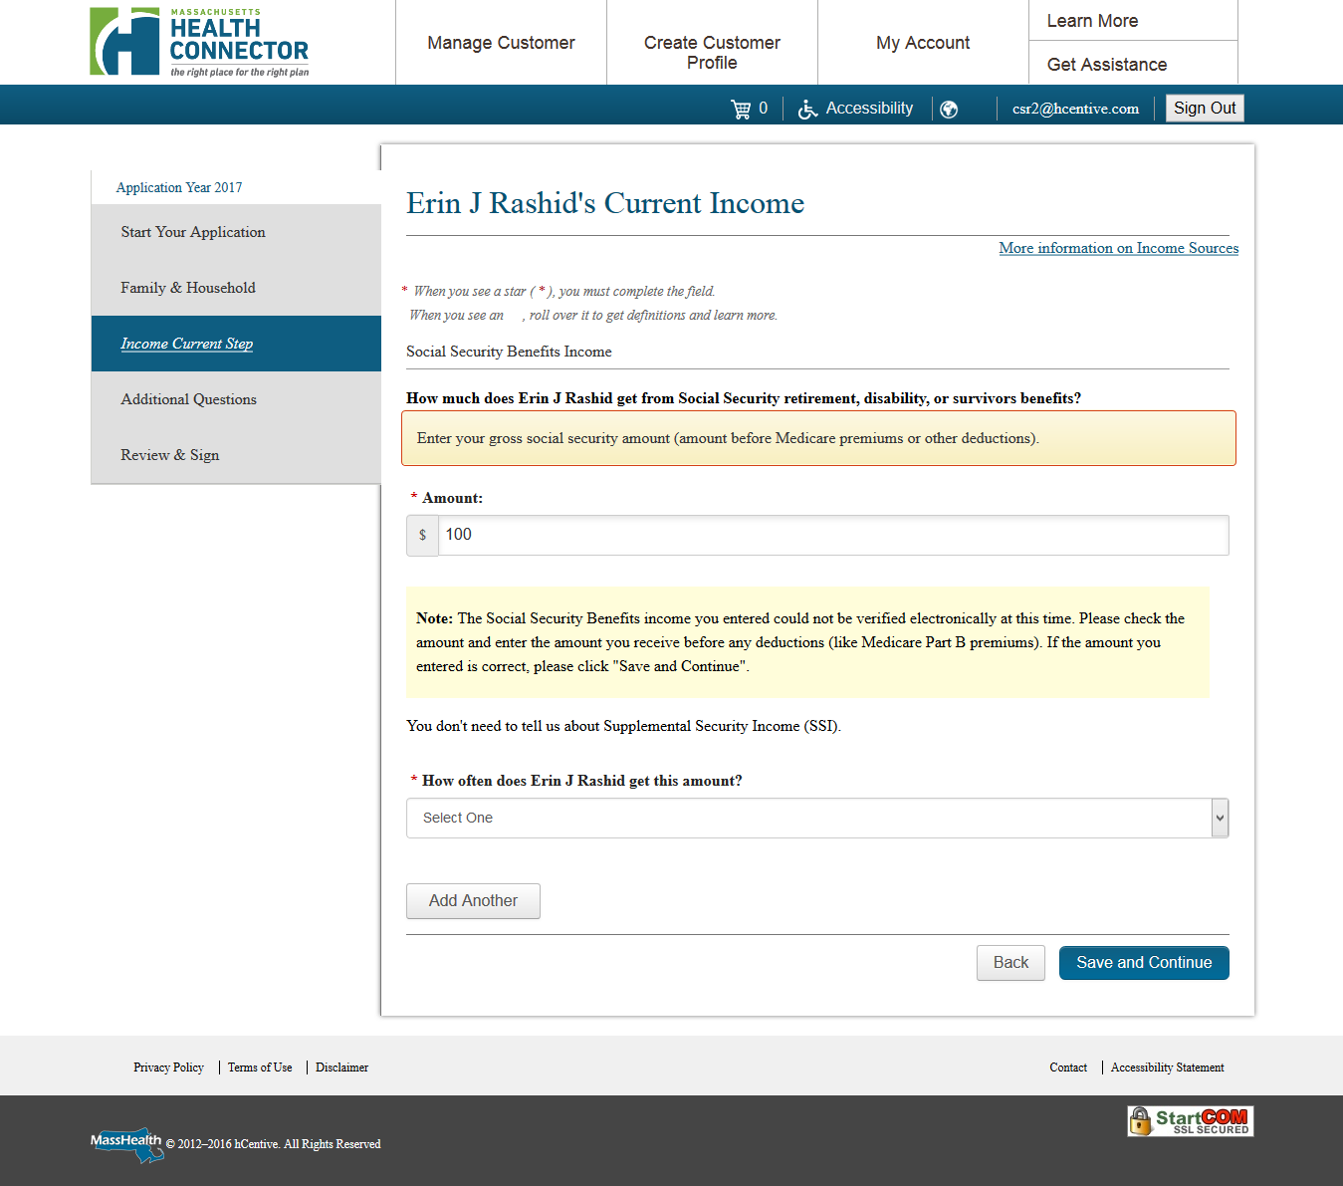

Figure 8| Income Alert Message 3

### Transaction /SSO Information

N/A

### Functional Requirements

|  |  |
| --- | --- |
| **Functional Requirement ID** | **Requirements** |
| CO.FR.03.01 | The system shall display an alert to the user when the system has Title II income returned from the Hub and the user selects 'No' to the question that asks the user if the member has any income. |
| CO.FR.03.02 | The system shall display the following alert message-  Based on information from federal and state data sources, we have information this person may receive income from Social Security.  If this is correct, please click YES to tell us about your Social Security income.  If this is not correct, please click Save and Continue. |
| CO.FR.03.03 | The system shall display the alert (CO.FR.03.02) prepopulated when the returning user navigates through this screen and Title II income returned from the Hub/Title II income available on the system differs from user attested Title II income. |
| CO.FR.03.04 | The system shall display a pop alert to the user when the user selects the source of income other than social security benefits on income section and the system has Title II income returned from the Hub. |
| CO.FR.03.05 | The system shall display the following alert message- Based on information from federal and state data sources, we have information this person may receive income from Social Security.  If this is correct, please click CANCEL to tell us about your Social Security income.  If this is not correct, please click OK to continue with your application. |
| CO.FR.03.06 | The system shall provide the ‘Cancel’ and ‘OK’ button on the popup alert.  Upon clicking the ‘OK’ button user will proceed with the selected income source. |
| CO.FR.03.07 | Upon clicking the ‘Cancel’ button user will remain on the same page to select the source of income. |
| CO.FR.03.08 | The system shall compare the user attested social security Title II income with Title II income returned from the SSA as per UC-02. |
| CO.FR.03.09 | The system shall compare the user attested Title II income with the Title II income on the application (it can be user attested at the time of original application OR updated via the PDM process OR manually verified by BO user) when the system does not receive any Title II income from the hub through the SSA composite service. |
| CO.FR.03.10 | The system shall display an alert to the user when there is a discrepancy between the Title II income returned from the SSA and the user attested social security (Title II) income.  After providing the Title II income details, the system shall display the alert to the user. |
| CO.FR.03.11 | The system shall display the discrepancy alert on the income section per member level. |
| CO.FR.03.12 | The system shall display the following alert message:  The Social Security Benefits income you entered could not be verified electronically at this time.  Please check the amount and enter the amount you receive before any deductions (like Medicare Part B premiums). If the amount you entered is correct, please click Save and Continue. |
| CO.FR.03.13 | The system shall display the alert (CO.FR.03.12) prepopulated when the returning user navigates through this screen if the Title II income returned from the Hub/Title II income available on the system is differ than the user attested. |
| CO.FR.03.14 | The user will be allowed to continue in application after choosing the appropriate action button on the discrepancy alert.  (It will not matter if the user has modified the Title II income or not.) |
| CO.FR.03.15 | The system shall utilize the user attested Title II income for eligibility determination if there is a discrepancy between the user attested Title II income and Title II income returned from the SSA. |
| CO.FR.03.16 | The system shall display an alert to the user when there is a discrepancy between the Title II income on the application (when the system does not have any Title II income from the SSA composite service.) and the user attested social security (Title II) income. |
| CO.FR.03.17 | The system shall not display an alert for the discrepancy between the Title II incomes (user attested vs returned from the SSA/Title II income on file) to the user when the trigger for eligibility determination is a batch process. |
| CO.FR.03.18 | The popup alert should be 508 compatible. |

Table 7. Functional Requirements – UC.03

### Special Design Consideration

N/A

### Acceptance Criteria

1. User attested Title II income should be compared with Title II income returned from the Hub through the SSA composite service when the user navigates through the SSN page.
2. The system should be utilizing the user attested Title II income in eligibility determination when the eligibility determination trigger is user driven.
3. The system should compare the user attested Title II income with the Title II income on the application (it can be user attested at the time of original application OR updated via the PDM process OR manually verified by BO user) when the system does not have any Title II income from the hub through the SSA composite service.
4. The system should be able to display an alert whenever the user selects no source of income and the system has Title II income returned from the Hub.
5. The system should be able to display an alert whenever the user selects the source of income other than social security benefits and the system has Title II income returned from the Hub.
6. The system should be able to display an alert whenever there is a discrepancy between the user attested Title II income with Title II income received from the Hub.
7. The user should be allowed to continue after the discrepancy alert. It will not matter if the user has modified the Title II income or not.
8. The system should be able to display an alert whenever there is a discrepancy between the user attested Title II income and the Title II income on the application (when the system does not have any Title II income from SSA composite service.)
9. The system should not display the discrepancy alert between the Title II incomes (user attested vs returned from the SSA/Title II income on file) to the user when the trigger for eligibility determination is a batch process.
10. The discrepancy alerts should be shown as displayed in the mockup.
11. The system should display prepopulated alert to returning user if the Title II income returned from the Hub differs from the user attested Title II income.
12. The discrepancy alert should be 508 compliant.

# Reference Document

|  |  |
| --- | --- |
| **Document Name** | **Document Attachment** |
| Scenario Sheet |  |
| URM Sheet |  |

Table 19. Reference Documents

# Acronyms

The Acronyms table provides a list of all acronyms included in the deliverable, along with the literal translation and definition.

|  |  |  |
| --- | --- | --- |
| **Acronym** | **Translation** | **Definition** |
| CAC | Certified Application Counselor |  |
| COLA | Cost of Living Adjustment |  |

Table 20. Acronyms